At St.Andrew’s church in Wickhampton, NR13 3PB, in Broadland
“ART , NATURE AND HISTORY”
Welcome to our new ART EXHIBITION –
Wednesday 13th June to Sunday 24th June
10.30am- 5.30pm
Paintings, prints, drawings, photographs and more;
In the calm peaceful setting of an old heritage church you can view unique
14 century wall paintings showing stories from the past,
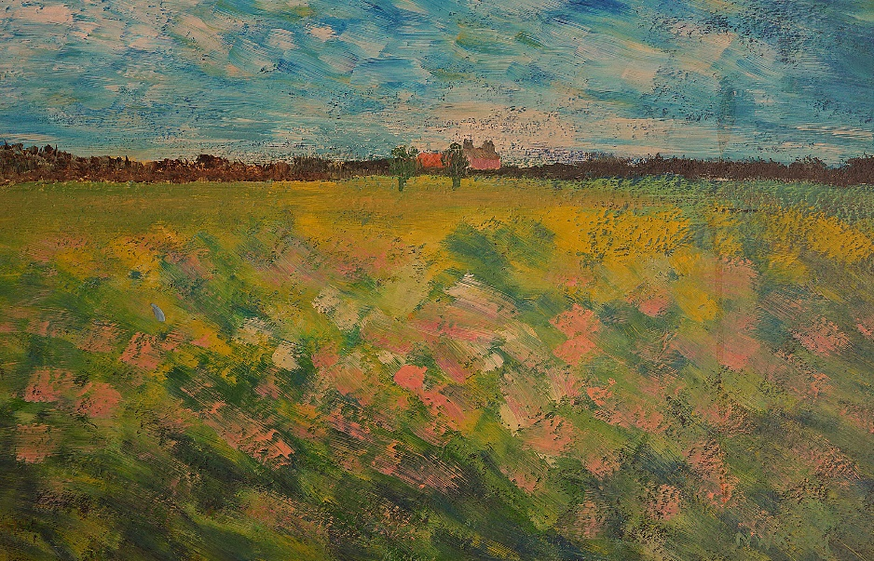
And there are beautiful walks on the Marshes – you can rest ‘away from it all’
Free Admission to the exhibition TOMBOLA Light Refreshments available
* * * On Friday 22nd June starting at 7.30pm - there will be a TALK:
“The Hazards of the Journey: the reality of PILGRIMAGE, travel and tourism in the Middle Ages” -By well-known
Art Historian Imogen Corrigan.
Tickets £ 5 each - will include Refreshments ; takings to go to church funds; You are very welcome to come at 6.30pm – to view
artwork ; Further details 0n 01493 700008 -messages possible;
OR email ekozmian@gmail.com

