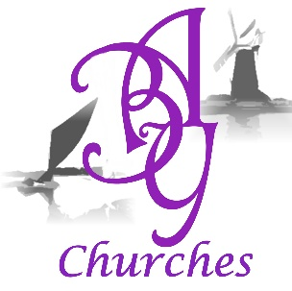
Acle and Bure to Yare Benefice Choir –

Report 2024 -5
The choir is directed by Dr Michael Nicholas, well known as a former ‘Master of the Music’ and Organist at Norwich Cathedral. We are accompanied at the Organ by several fine organists, of whom the most regular is Timothy Patient. We consist of regular singers supplemented by other skilled musicians, some of whom are called in for the very last rehearsal – we are nearly always short of Basses and often of Tenors too. The singers are drawn from a wide area, with just a few actually living in the Benefice, so we are very grateful to those who come, sometimes from a long distance, to make the Choir viable. We usually meet on a Monday evening at Acle when actually practising for an event, with final rehearsals being at the relevant church.
As reported last year, on 12th May 2024 we sang at Great Yarmouth Minster, with a mixed programme including exerts from Fauré’s Requiem. We started rehearsing again in August and sang Choral Evensong for the Feast of St Matthew at Wickhampton Church on Saturday 21st September, and then, just under a week later, sang Evensong at Norwich Cathedral. Practices started again in early November for the Advent Carol Service at Reedham Church on 6th December. This gave an opportunity to sing some of the lovely pieces more appropriate to that season than the usual Christmas Carols, such as the Palestrina Matin Responsary , Richard Rodney Bennett’s ‘Out of your sleep’ and Joubert’s ‘There is no rose’. The Choir procession from the West end was led by our Crucifer and Benjamin, Daisy and Charlotte Lonsdale as Candle Bearers.
This year, 2025, we marked Good Friday, again at Reedham Church, with exerts from Handel’s ‘Messiah’, interspersed with readings of the texts from which the Arias were taken. The second half included pieces by Byrd, Ireland and Stainer with readings from George Herbert and T.S.Eliot’s ‘Murder in the Cathedral’.
We are now rehearsing for Sung Eucharist for Ascension Day at Norwich Cathedral. Unfortunately, this clashes with the Deanery Holy Communion at Postwick, so we may not be appearing as the ABY Choir on the day.
Thanks are due to Kate Ashcroft, who brings her electric Keyboard to practices – this has made it much easier for the Choir and for Michael. Thanks also to the choir members and their tolerant partners. Many, many thanks to Michael Nicholas, as ever, who shares his amazing musicianship and experience so freely and with an energy which belies his years.
Kati Cowen, Choir librarian, Mistress of the Robes and general factotum.

