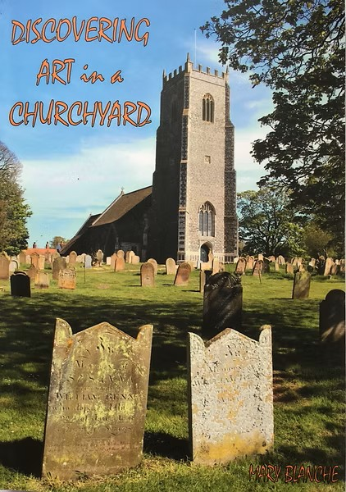
For those who are seriously delving into their Reedham family history, the book ‘Discovering Art in a Churchyard’ could well be an additional help and advantage. This book, written, compiled and published in 2020 by Mary Blanche, describes the art of sculpting by stonemasons of the past and mostly the older Headstones in Reedham churchyard have been used for that very purpose. The beauty of the chosen designs by the stonemason’s lettering in different fonts, meaningful sculpted flowers and leaves, symbolisms -and all explained in the book, may well feature one of your ancestors.
When looking through this book you can almost feel you’re actually walking in this sacred place and experience the tranquillity around you and fill you with an aura of peace…
If interested to purchase this book, please message me via Facebook.
Many thanks,
Mary Blanche

