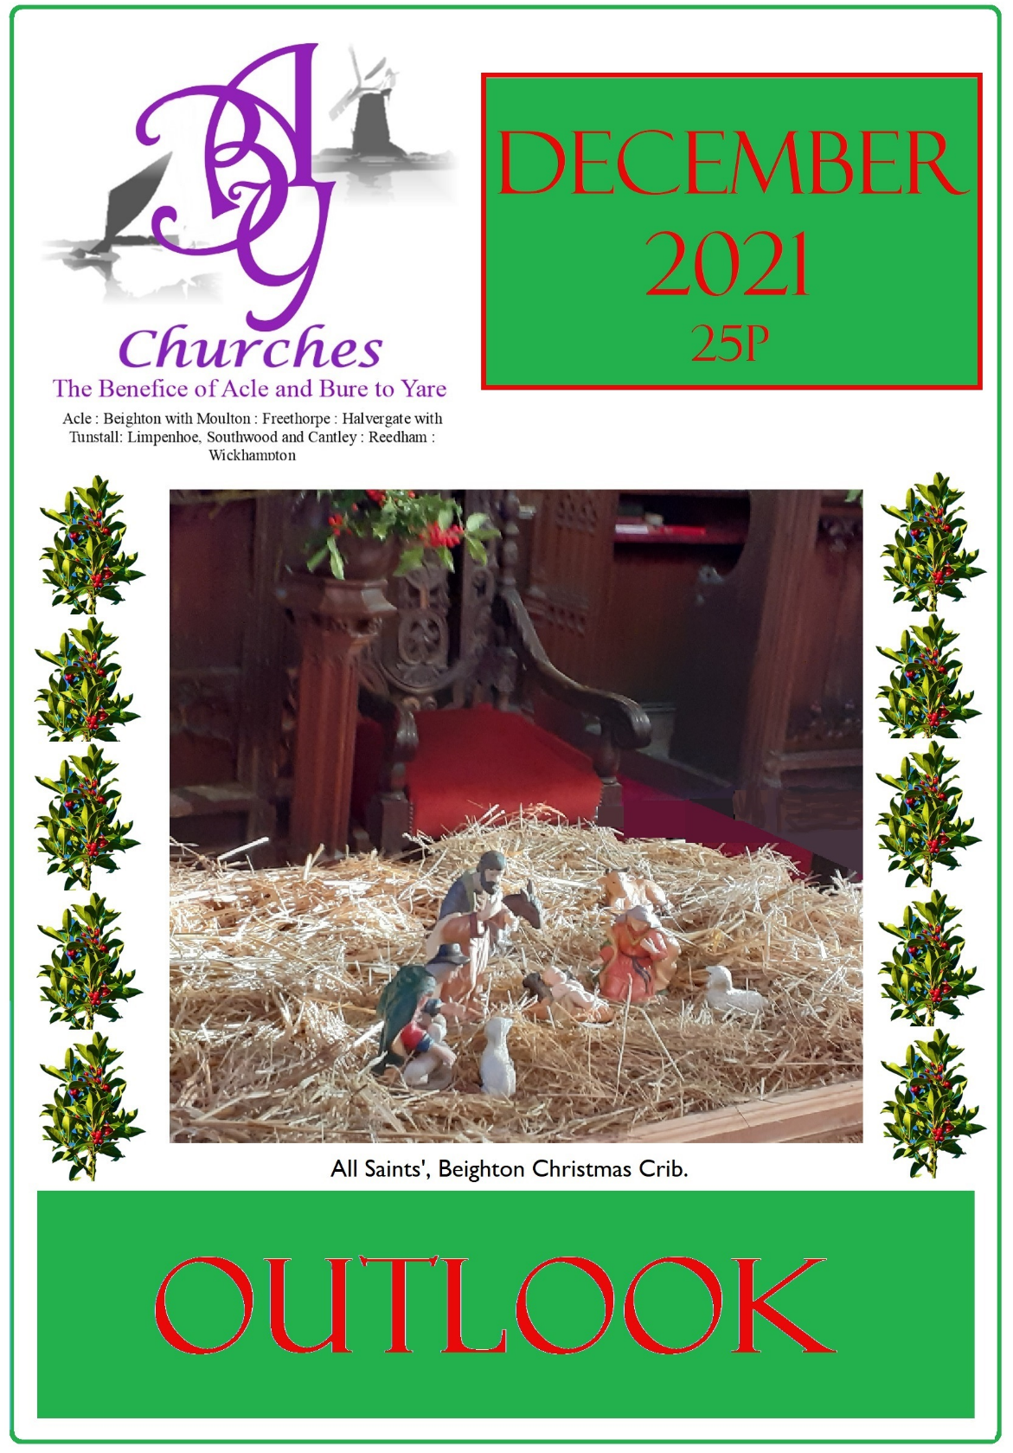
ACLE & BURE TO YARE BENEFICE: WHO’S WHO 2.

RECTOR: Rev’d Martin Greenland, 01493 750393 rector@aclechurch.plus.com

READERS: Nicholas Cowen, 01493 700915
Vic Walsham, 01493 752273

CHURCH WARDENS:
Acle | (Vacant)
Beighton | Ann Adey 01493 700414  Rosemary Whyborn 01493 750079
Freethorpe | Graham Allcock, 01493 700256
Halvergate | Nick Butcher, 01493 701122
Limpenhoe | (Vacant)
Reedham | Kati Cowen, 01493 700915  Jonathan Lonsdale 07939 082424
Wickhampton | Brenda Pawsey, 01493 700068  Peter Ledward, 01493 700008

ACLE PARISH HALL Mrs Page 01493751125/07947889652

“OUTLOOK” EDITORS:
Kati Cowen | 18 Church Road, Reedham, NR13 3TY, 01493 700915  e-mail: kncowen@tiscali.co.uk
John Orsborn | 18 The Hills, Reedham, NR13 3TN, 01493 700441
“OUTLOOK” ADVERTISING EDITOR:
Jonathan Lonsdale | e-mail: jnlonsdale@me.com
Website | www.abychurches.co.uk/ (Digital copy of Outlook)


Give Today to Support your Local Church
Scan the QR Code with your Smartphone to go directly to the Diocese Website to make a donation – you can specify to which church it goes.

From the Rectory 3.
Back to normal?
No doubt there will be a lot of smiles as we celebrate Christmas in ways denied us last year – singing carols in church, for example. While there may be expectations from some that things will be “back to normal” this year, that won’t be the case everywhere, or for everybody. While some are all too ready to place full reliance on vaccines and throw caution to the wind (along with their face mask) others are more apprehensive – sometimes with good reason: Covid 19 is still claiming lives. Things are not back to normal in schools, with the risk of unvaccinated children spreading the virus not only amongst themselves, but to associated adults: many Christmas performances will be on-line this year (and for the same reason we’ve decided not to go ahead with the usually well-attended Christingle at St. Edmund’s this year). Hospitals are anticipating severe pressure, not particularly from Covid, but from heightened levels of everything else, under Covid conditions. I’ve a 3-month gap between check-up and follow-up treatment at my dentist – I’m sure others have had more significant medical postponements. At least we’re told that turkey supplies have been safeguarded …
As last year, I’m reminded that the Christmas stories in the Bible are made up of a whole series of disruptions, from angels breaking in on Mary, Joseph and the shepherds, to the upheaval of the census and the mission of the magi. And that’s before the flight to Egypt and the massacre of the innocents. We’ve made a tradition of Christmas, when we hanker for the comfort of the familiar. But the event of God breaking into human life was far from normal and far from comfortable: “A cold coming we had of it,” says T.S. Eliot’s magus. Fear is the usual first reaction to the unfolding narratives. It turns to joy: but it’s the joy of discovery, not the comfort of the familiar. It makes the point that the coming of Christ into the world was momentous, unprecedented and off-centre: nothing normal about that.
Things do eventually settle down, with Jesus receding into a presumably unremarkable childhood (though there are non-biblical texts which would have it otherwise). But nobody who has participated is unaffected: the shepherds can’t get over what they’ve seen; Mary tries to make sense of it all; while the magi return home another way, Eliot speculating that they would be “no longer at ease … in the old dispensation.”
The incarnation says something wonderfully affirmative about human being: that it can carry the image of God. Yet Jesus comes, not to endorse us as we are, but to restore us to what we are intended to be: the second Adam reversing the fall of the first. Medieval carols celebrate that enthusiastically: may your Christmas be equally joyful; not because we’re back to normal, but because the birth of Jesus recalls us to who we truly are.
In the love of God,
Martin Greenland

Parish Registers 4.
Holy Matrimony
Robert Hugh Pellow and Rebecca Verity McKnight on 23rd October at St Peter and St Paul’s, Halvergate

Funerals
We commend to God’s keeping:
John Henry Guymer, aged 86, on 25th October at St Botolph’s, Limpenhoe.

Lorraine Ann Mallett, aged 76, on 4th November at St Peter and St Paul’s, Halvergate.

David Alan Hollis, aged 76, on 16th November at All Saints’, Beighton.

St Edmund’s
Thank you very much to all who distributed or donated to St. Edmund's Gift Day. At the time of writing, I know of donations totalling over £1,800 (and it’s not too late to send something!) If you missed out on the letter to parishioners it's at www.abychurches.co.uk/whats-on/events/

Having only one priest in the benefice and with no other priest available this year, there will be only one Christmas Eve Midnight Holy Communion, to which all are welcome: at Halvergate. At the same time (11.30pm) the traditional service of Readings & Carols will be celebrated at Limpenhoe.
Martin
Rose Charity - Reedham
The Charity of John Rose was established by the Will of John William Rose, following his death on 5th March 1920. He left the sum of £500 to be invested by the Trustees (the Rector and Church Wardens of Reedham Church). The interest was to be used at Christmas or during the Winter for ‘provisions, blankets, warm clothing’ for the ‘deserving poor’ of the parish, ‘irrespective of creed’.
As you can imagine, the interest from £500 doesn’t amount to much these days – it would have been less than £1 for the current year. For some years no distribution has been made, the sum being so low; this was added to the capital. The Trustees therefore have decided to close the charity, making a final distribution by way of supermarket vouchers and sending the £500, in accordance with the terms of the Will, to the Norfolk and Norwich Hospital.
The Rose family lived at Park Hall, now the site of Hall Farm, during the 19th Century. They built housing for their workers, identifiable by the initials JWR, and their tombs are next to the Rose Room extension in Reedham Churchyard.
The Trustees
Outlook Copy Date for January Magazine
As usual, this is at the earlier date of 14th December – but please could we have any photos even earlier – 12th at the latest.
Many thanks to those who have contributed, folded, distributed, subscribed and read over the last year, and we wish you all a Blessed Christmas and a prosperous New Year.
The Editors



5.

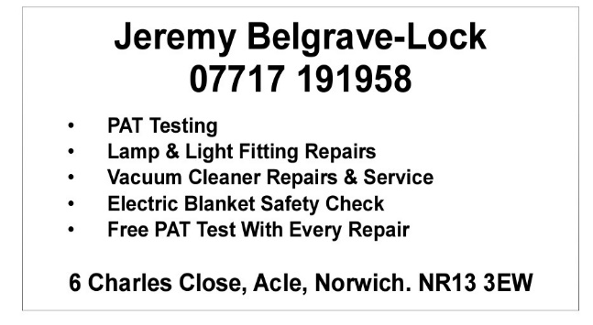





6.

A hymn Tune puzzle. 7.
Shown below are two alphabetical lists. The left-hand list has the opening words of hymns and the right-hand list has the hymn tunes. Match the tunes to the words. Also take the first letters of each line of the left list and rearrange to spell out a seasonal phrase.

Abide with me | Bristol
Come let us join our cheerful songs | Bunessan
Eternal Father, strong to save | Darwall’s 148th
Hark the glad sound | Eventide
Immortal, invisible | From strength to strength
Morning has broken | Gopsal
My God how wonderful Thou art | Melita
Rejoice the Lord is King | Nativity
Ride on ride on in majesty | Northampton
Rock of ages | Petra
Soldiers of Christ arise | St Denio
Songs of praise the angels sang | Westminster
Through all the changing scenes of life | Wiltshire
Ye holy angels bright | Winchester New
Answers next month.
Lyndsay Fisher
Reedham Station Adopters
Hello everybody. A little update on your station. The majority of the Adopters are busy keeping the gardens looking tidy. Thank you all for all your plant donations in the past – a special thank you to Audrey on Station Road. That you to Cate for her gardening efforts and Zoom meetings with Greater Anglia and to Colin for his gardening efforts throughout the pandemic. Hopefully we will be able to hold events again one day. Wishing you all a safe and Merry Christmas.
Michael Stoker (Chair) and Adopters.
Original Charity Christmas Card Shop
It is situated in Peter Mancroft Church and open from 10-30am to 2-30pm Monday to Saturday, until 18th December.
Over 20 charities , who are either local or have a Fundraising Group in Norfolk have their cards there including EACH, Air Ambulance, Livability, Norwich Food bank, Save the Children, Priscilla Bacon Friends of Norwich Cathedral, John Aves Educational Trust and Guide Dogs for the Blind.
Every penny from the sale of cards goes to the charities due to the generosity of the PCC of Peter Mancroft and the Shop volunteers.

Acle and District Royal British Legion (see photo on back cover)
On the morning of Thursday November 11th at Acle War Memorial Centre, Mark Lockwood chairman of Acle Branch of the Royal British Legion conducted a short service to commemorate Remembrance Day in front of a small crowd.

He recited 'The Exhortation' and 'The Kohima Epitaph' with the usual one minute and two minutes silences observed.
John Kenny
DECEMBER CALENDAR & CHRISTMAS SERVICES 8.
Reedham Charity: The Fishermen’s Mission
SUNDAY 5th | 9.30am | Morning Prayer – Halvergate
2nd of Advent | 9.30am | Holy Communion – Limpenhoe
 | 10.30am | Carols – Freethorpe Village Hall | 
 | 11.00am | Morning Worship – Acle
 | 11.00am | Holy Communion – Beighton
 | 4.00pm | Christingle – Reedham
 | 7.30pm | Cash Bingo – Beighton Village Hall
Monday 6th | 7.30pm | Reedham Parish Council – Village Hall
Saturday 11th | 9am to | 12 noon. Farmers’ Market – Acle Church Hall
 | 6.00pm | Carols at the Xmas Market with Broadland Brass – Acle Recreation Hall Car Park
SUNDAY 12th | 8.00am | Holy Communion – Acle
3rd of Advent | 11.00am | Holy Communion – Freethorpe
 | 4.00pm | Carol Service – Wickhampton
 | 6.30pm | Candle lit Carol Service at Freethorpe Methodist Church
Monday 13th |  | MOBILE LIBRARY DAY
Tuesday 14th |  | OUTLOOK COPY DATE
Friday 17th  & | 7.30pm | RCA Stage School – A Christmas Carol
Saturday18th | 7.30pm | - Reedham Village Hall
SUNDAY 19th | 9.30am | Holy Communion – Halvergate
4th of Advent | 11.00am | Nine Lessons & Carols – Acle
 | 11.00am | Holy Communion – Reedham
 | 11.00am | Messy Church Christmas Service – Freethorpe Methodist Church
 | 2.30pm | Carol Service with Nativity – Limpenhoe
 | 2.30pm | RCA – A Christmas Carol
 | 4.30pm | Christingle & Carols – Freethorpe
Monday 20th | 7.30pm | Cash Bingo – Reedham Village Hall
 |  |  | 9.
Wednesday | 3.00pm | Carol Service – Beighton
22nd | 7.30pm | Christmas Quiz – Reedham Village Hall
Thursday 23rd | 7.00pm | Readings & Carols with ABY Choir – Halvergate
Friday 24th | 4.00pm | Crib Service – Reedham
Christmas Eve | 11.30pm | Midnight Holy Communion – Halvergate
 | 11.30pm | Midnight Service – Limpenhoe
Saturday 25th | 8.00am | Holy Communion (BCP) – Acle
Christmas Day | 9.30am | Roman Catholic Mass – Acle Church
 | 10.00am | Family Service – Freethorpe
 | 10.30am | Family Service – Acle Methodist Church
 | 11.00am | Holy Communion – Reedham
Sunday 26th | 11.00am | Benefice Holy Communion – Acle
St Stephen
Looking into | January:-
SUNDAY 2nd | 9.30am | Morning Worship – Limpenhoe
The Epiphany | 11.00am | Morning Worship – Acle
 | 11.00am | Morning Prayer – Beighton
 | 11.00am | Covenant Service – Freethorpe Methodists

WICKHAMPTON CHURCH CAFÉ

The Wickhampton Church Café will be open for refreshments on Saturdays and Sundays, from 10am to 2pm, beginning on Saturday 4th December 2021.
Why not drop in for a cuppa, a cake and a mardle? We’ll be pleased to see you!
The Friends of Wickhampton Church
Wickhampton
All are welcome to St Andrews Church, Wickhampton to our Christmas Carol Service on Sunday 12th December at 4pm with the Handbell Ringers
Mince Pies and Punch will be served around the Christmas Tree at the end of the service.
WICKHAMPTON CHURCH TEA TOWELS 10.
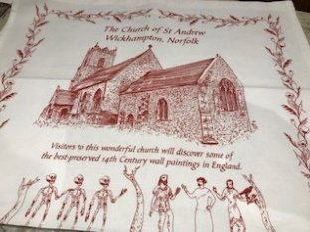
These unique, 100% cotton tea towels - depicting the wonderful 14th Century wall paintings in St Andrew’s Church – are the perfect stocking-filler, and very handy for all that drying up at Christmas!
£5 each (plus postage if applicable).
To order: 07894 993920 or email: wickhampton@gmail.com

Freethorpe Village Carols
The Village Carol Service in Freethorpe Village Hall on Sunday 5th December at 10.30 a.m. This is a united Carol Service with Freethorpe Anglican and Methodist churches taking part. The parish churches of Reedham and Halvergate are invited to be with us.
We welcome all parishioners in the surrounding villages to join us in this service, which marks the beginning of the Christmas season.
Corinne Hill
Methodist Church Steward
Reedham Gardening Club - Jobs for the garden in December
Continue to cut back faded Herbaceous perennials and add them to the compost heap or leave them till spring to be used by insects as a winter home.
In mild weather, and during dry spells, you can still lift and divide herbaceous perennials. This will increase stocks, and revive tired or poorly flowering clumps.
Large tubs that are at risk from cracking in the frost should be covered with bubble wrap, hessian or fleece, to insulate them over the winter. Tender plants and pots can be brought into the greenhouse or conservatory if not done so.
Prune open-grown pear and apple trees - Not those trained against walls.
Harvest leeks, cabbage, parsnips, sprouts and remaining root crops.
The Gardening Club would like to wish everyone a very Merry Xmas and a Happy New Year.
Followed by Mulled Wine &
Mince Pies in the Village Hall
Family Church at Reedham this Christmas

Sunday 5th December 4pm
CHRISTINGLE SERVICE
* darkness * oranges * candlelight procession *
* take home your very own Christingle *

Friday 24th December 4pm
CRIB SERVICE
* come and hear the lovely Christmas story *
* place the figures in the Christmas crib *
* and sing some of your favourite carols *

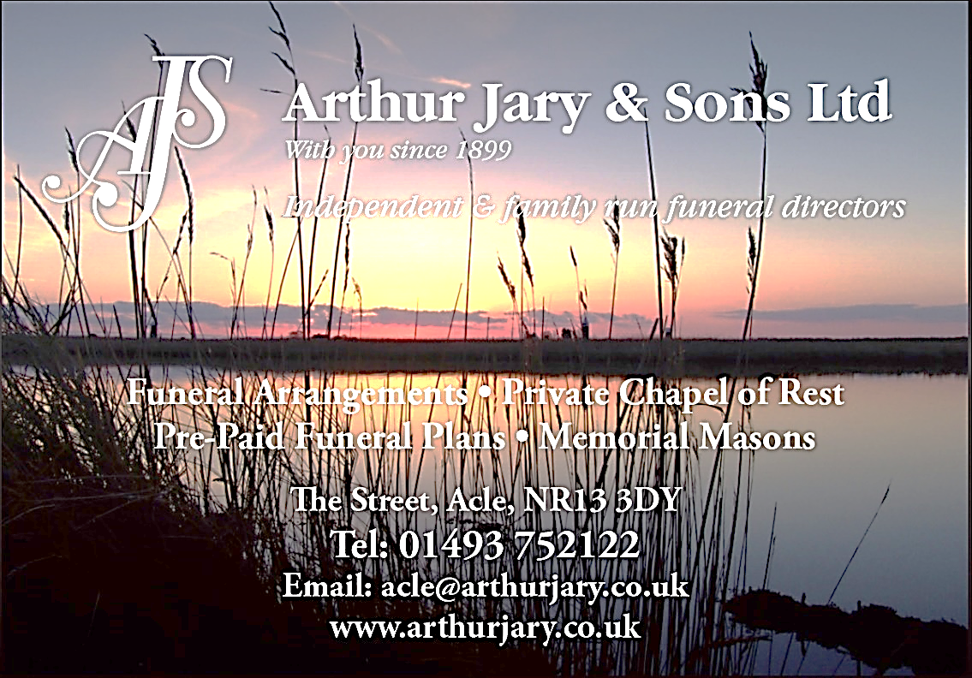
11.

12.

DECEMBER 2021 - BREWERY SHOP
OPEN EVERY DAY 12-5PM UNTIL & INCLUDING CHRISTMAS EVE
With a wide range of bottled beers, ciders & gins; wines, fizz & liquers;
honeys, syrups & preserves; chilli sauces, dressings & oils;
chocolates, cookies & lots of gift ideas.
OPEN WEEKEND
4 -5 DECEMBER 2021 12-5PM
Meet the team, try the beers, tour the brewery.
Snacks & hot food, hot & soft drinks also available, plus the shop will be open
for Christmas shopping & to order your Christmas beers!

More information: www.humptydumptybrewery.co.uk
or call 01493 701818

Church Road, Reedham, NR13 3TZ (next door to Pettitts)

THE RISE AND FALL OF FLORAL FOAM. 13.
This article was written for The Costessey Flower Club November Newsletter by Doris Waymark. She was the founder chairman of this club and it will be celebrating its fiftieth year in 2022. Doris is proud to be its Life President and still enjoys the demonstrations and all the friendships she has made over the years in NAFAS. Doris has given me permission to share the article to be published in the Outlook magazine.
Today, flower arranging is often considered to be a modern art. This is not so – cutting flowers and placing them in a receptacle containing water has been done throughout the ages. In early times, it was mainly religious and symbolic, carried out in churches and public buildings. In the Middle Ages it was developed as a Domestic Art,
Each period developed its own style. A variety of containers that could hold water were used from ornate colourful vases and urns, to everyday bowls, jugs etc. If the container was a large and deep bowl, jam jars filled with water were stuck to the bottom with plasticine. Over the years various devices have been used to hold stems firmly in place, such as sand, moss, bark and crumpled wire netting. The ancient Chinese cut forked twigs to use as supports and in the early 19th century they devised a copper disc on which a number of nails were glued upside down-the forerunner of the pin holder that became very popular. It was the late Victorians who invented the glass rose top with holes in to place on top of the container. Later, wire netting was made into a frame to serve the same purpose, as was sticky tape criss-crossed and secured by rubber bands or string.
The dramatic change took place in the 1950’s when flower arranging became very popular. Flower Clubs were formed and not just as a pastime for ladies of leisure. Flower arranging classes were organised and in 1959 NAFAS was formed. In the early days, classes used containers home made from painted food tins etc. and using sand, moss and wire netting.
In 1954, when Floral Foam was invented in America by Smithers-Oasis, life for the flower arranger became so much easier. Its use allowed more adventurous and varied designs to be created and with the manufacturers bringing onto the market purpose-made containers and other products including dried and coloured foam cases and tape, the art of flower arranging knew no bounds.
As so often, there was a downside. Oasis takes 100 years to degrade in land fill. In our more environmentally conscious society, this is no longer considered to be acceptable. So where do we go without Oasis? It will make life quite difficult and challenging for demonstrators to vary their designs. Already though, we are seeing demonstrators doing some foam free arrangements - for example, hand-tied bouquets. It is changing the design and development of arrangements to enable them to be foam-free. So, we can look forward to the future of arranging with optimism!
Margaret Allcock.

Bingo at Beighton
On Sunday 5th December at 7.30pm there will be Cash Bingo at Beighton Village Hall. Doors open at 7pm.

First Freethorpe Guides & Rangers
The Guides and Rangers collected £367 for the Poppy Appeal in the village of Freethorpe. Well done to all. Guide Leaders.

Over Fifties Club (see also back cover) 14.
Well, we have had a few busy weeks since the last Outlook. We have had birthday parties and a Halloween party. Marion and Barbara both had birthdays with buffet food and a birthday cake. Then at the end of the month we had a wonderful Halloween party again with buffet food. Both occasions were enjoyed by all members and the afternoons were filled with laughter. Various members came in fancy dress for the Halloween party.
We are now looking forward to our Christmas party at the hall and a Christmas lunch at Acle Bridge. At our Christmas party there will be a grand raffle and all members are asked to bring a prize of Christmas Fayre namely biscuits, chocolates, wine etc.
The members are all asked to sell raffle tickets to help club funds. The person who sells the most will be given a prize.
Members were given their club calendars with photos of club events. All these events and the calendars are free to members.
We close the club after our Christmas party at the hall and we will re-open on January 4th 2022. If you would like to join our ever-growing family come along to Reedham village hall on a Tuesday at 1.30pm to sign up for membership. The 2022 membership fees are £7.00 for the year and £2.50 per week. Don’t sit alone at home come and join us.
LOTTERY NEWS
As this goes to print on November 16th our lottery has not been won. This particular game has run 10 weeks so far and the jackpot if won will be over £400. Obviously it grows each week so the longer it goes it will keep growing. This helps support our club and various other charities are supported. This is open to non-members as well and if you would like to join please contact me on 07585504199. You have to be in it to win it!
Angie Woolsey Secretary / Treasurer
REEDHAM PARISH COUNCIL
Meeting held on Monday 1st November 2021 in the Village Hall.
There were 7 Councillors present, the Clerk, District Councillor Grant Nurden, and 4 members of the public. County Councillor Lana Hempsall attended virtually. The meeting commenced at 7.30pm

There is a vacancy for a Parish Councillor. If you are interested or would like further information please contact the Clerk. Applications will be considered at the next Parish Council meeting on Monday 6th December.

Norfolk County Council have launched an Electric Vehicle Charging Strategy to improve the network round the County. A grant has been received from the Department for Transport which has reduced the costs from £6,000 per charging point down to £1,500.

Chairman of the Village Hall Committee Chris Bradbury gave the following report:
The play equipment safety inspection has not yet taken place for this month.
The goal posts have been taken down on the playing field as rot was found in the metal posts and they were considered unsafe.
The psychic medium night in October was very popular with nearly 90 people in attendance.
The October Cash Bingo Jackpot wasn’t won so the jackpot now stands at £220 in 47 numbers or less.
Our Halloween Quiz Night was well supported with 10 tables taking part.
2 planning applications were considered:
- BA/2021/0406/HOUSEH –erection of a single storey flat roof garden room 15. extension to the rear with lantern lights at The Fourth House, 25 Riverside. The Council resolved no objections.
- 20211838 – extension to existing rear conservatory at Kimberley, 41 The Hills, NR13 3AR. The Council resolved no objections.
1 application received after the agenda was published was considered:
- 20211314 – re-consultation on construction of first floor side extension at 33 Station Road, NR13 3TB. The Council suggested there were no further comments necessary. To be approved at the December meeting.

The Neighbourhood Plan steering group is currently concentrating on identifying and assessing important views and green spaces in the village, and heritage assets. Their next meeting will be on the 29th November at 7.30pm in the Village Hall. All residents are welcome to attend.

The War Memorial has been cleaned and the lettering repainted. The fence along The Hills has also been repaired.

The meeting dates for 2022 were approved by the Council:
January – Monday 10th  February – no meeting  March – Monday 7th  April – Monday 4th  Annual Parish Meeting – Monday April 11th  May – Monday 9th – Annual Parish Council Meeting | June – Monday 6th  July – Monday 4th  August – no meeting  September – Monday 5th  October – Monday 3rd  November – Monday 7th  December – Monday 5th
Time and Date of Next Meeting.
Monday 6th December 2021 at 7.30pm in the Village Hall. Further details will be published on the website, Facebook page and noticeboard by the Doctor nearer the time. All parishioners are welcome to attend.
DOG FOULING IS AN OFFENCE. PLEASE CLEAR UP AFTER YOUR DOG.
THERE IS A £100 FINE IN BROADLAND FOR NOT CLEARING UP AFTER YOUR DOG IN A PUBLIC SPACE. IF THERE IS NO BIN NEARBY TAKE IT HOME WITH YOU.
This continues to be a problem round the village and the Parish Council is considering what further action may be able to be taken.
The Clerk’s contact details are: reedhampc@outlook.com or 07769 972902

Reedham Village Hall
Events coming up at the village hall:-
Monday 20th December Christmas prize and Cash Bingo eyes down 7.30pm - look out for posters with jackpot details
Join us for a Christmas Quiz Night at 7:30pm on Wednesday 22nd December start approx. £2 a person. Maximum team of 6.
Prize for the best fancy dressed team.
To book call 01493 701107.
Cash or card payments will be accepted for entrance fee on the night.
RCA Stage School presents A Christmas Carol on Friday 17th Saturday 18th December at 7:30pm and Sunday 19th December at 2:30pm. Tickets cost £2.50 for under 16 and £5 for 16 and over. Either book online at www.ticketsource.co.uk/reedham-community-association or call 01493 701107.
Like to either Sing, Act or Dance then come along and join RCA Theatre company on Tuesday evenings at 7:30pm. £5 a month. Contact RCAstageschool@yahoo.com for more details.
