**Reedham Ringers**

The Reedham Ringer came together in 2018 with the express intention to ring church bells to mark the 100th anniversary of the 1918 armistice. Some of us were complete novices, a couple had rung as teenagers in the 1960s but not since, a couple rang the Reedham bells following the 1984 augmentation, and one was actually a ringer with considerable experience.

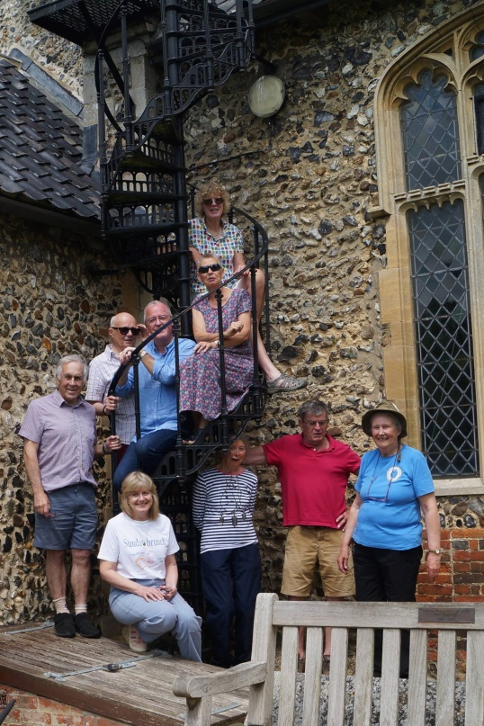Somehow we have managed to stick together, surviving a worldwide pandemic that decimated many bands with far more of a history than ourselves. 2025 has been a good year for the Reedham band. We lost a member who had returned to ringing after a 60 year gap, but our loss was a gain to the band at Ash in Kent, where Chris relocated. Two volunteers, who do not ring themselves, have increasingly taken over responsibility for the maintenance of the Reedham church bells, as David, our dedicated Steeple Keeper winds down.

The Reedham Ringers summer outing – Shotesham tower

We have rung for church services, for weddings and tolled to announce the passing of village residents. We have marked public events such as the 80th anniversary of the USAAF plane crash in February 2024, when the bells of St John the Baptist rang out before the very moving memorial service which was held at the village war memorial. A ghostly echo may have been heard from across the river at Norton Subcourse, as another, more experienced band of our ringing friends rang a peal, which is the marathon of bell ringing – 3 hours of uninterrupted ringing with not a single row repeated.

At Christmas, a band comprising bell ringers as well as members of the benefice congregation, rang handbell carols at various carol services, including Beighton and Swallowtail Place, where we were happy to entertain a large congregation of residents who joined in lustily singing to our accompaniment.

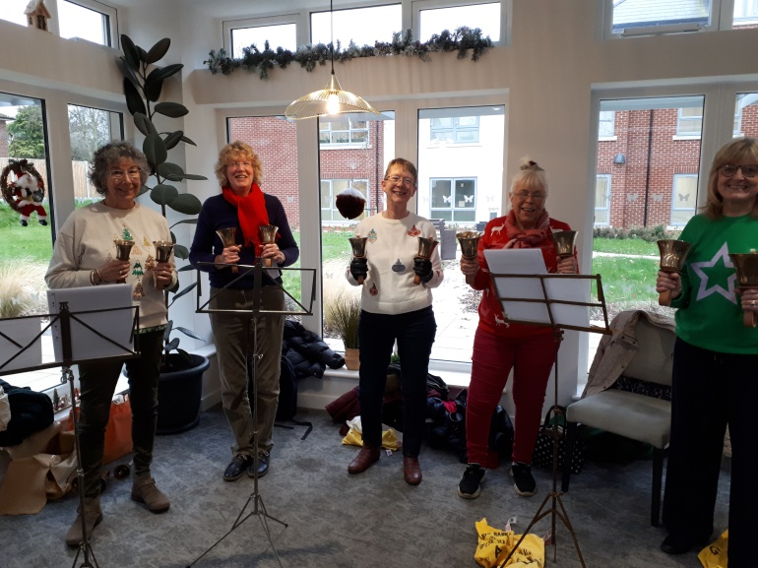We have three towers with bells in the benefice and try to ring them when needed. Thus we have rung for weddings at Acle, Halvergate as well as at Reedham. In this we are often helped by local, more experienced ringers, who can be called on to eke out the band when required.

Christmas carols at Swallowtail Place

All in all, the bellringers based at Reedham church continue to thrive. 2025 marks the 200th anniversary of the re-casting and re-hanging of the bells. Five of the bells were manufactured by Thomas Mears of London on 1825 and the same bells have rung out across the village for 2 centuries. That is something to celebrate and we intend to do so in style. The Humpy Dumpty brewery is brewing a special mild ale, named Heavy Metal, in their honour. It will be available on May 18th, Bell Sunday, the day that communities across the world are encouraged to celebrate the contribution of bells and bell ringers to their lives. There will be a short service at 11.30am led by the Bishop’s Chaplain since Martin is not available, followed by open ringing by any local ringers who are able to come along, after which ringers and congregation can retire to the brewery to sample the ale. Please come and join us! In the afternoon, we are inviting local people to visit the church, to view the bells and perhaps try their hand at chiming. Unfortunately, we do not have sufficient bells to ring Happy Birthday, but perhaps we can dust off the handbells and let people try their hand at those.

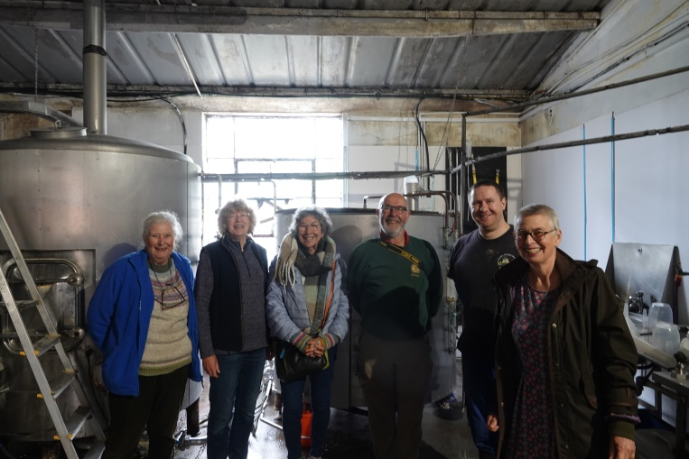Bellringing is a fascinating and rewarding hobby. The tradition stretches back over centuries and the patterns and, in many cases the equipment, have not altered over that time. If I were to join in ringing with the band that rang at St John the Baptist church in 1825, the bells and the music would be identical, although the presence of a woman in the ringing chamber would be a complete novelty and probably cause some gentlemen to down tools and refuse to join in. Thankfully, times have changed, and everyone is welcome to explore the art of bell ringing. You have to be big enough to reach the ropes (9-10 is a good starting age) and fit enough to climb the stairs. Training can be provided by local accredited Association of Ringing Teachers and there is a world-wide community of ringers ready to welcome you.

Humpty Dumpty brewery creates Heavy Metal

We practise every Monday at Reedham church between 4-5.30pm. We are a friendly group who enjoy ringing together and are keen to share what we do with others. If you are interested, please drop in any Monday to see what we do. I can almost guarantee that you will leave with a smile on your face. If you are working during the week, there are teaching sessions at St Peter Mancroft church on Saturday mornings and a junior group for under 18 year olds on a Wednesday after school. We need more ringers because our age profile is high. Training takes time and natural wastage means that we may not all be around to keep the bells ringing far into the future.

Mary Jones

Reedham Tower